Glow UP Campaign Analysis

Business Scenario
Glow Up, a beauty and skincare startup that recently ran multiple online and offline marketing campaigns. The company spent a significant budget on social media ads, influencer collaborations, and local events. Management wants to understand which campaigns delivered the best return on investment (ROI) and how to allocate marketing budgets efficiently in the future.

Project Overview
The Analysis focuses on the following objectives.
- Identify the most effective campaigns in terms of conversions and revenue.
- Calculate ROI for each campaign.
- Recommend budget allocation for future campaigns to maximize impact.

Dataset Description.
- Source of data – Kaggle.com
- Time Period – 2024 – 2025
- Rows – 1000
- Columns -- Campaign ID, Campaign Name, Start Date, End Date, Channel, Spend, Leads Generated, Conversions, Revenue Generated, Clicks, Impressions

Tools Used
- Microsoft Excell -- Used for initial data exploration, structure checks, and basic data cleaning. Helped identify missing values, duplicates, and inconsistencies in raw data.
- Python (Pandas, Matplotlib, Seaborn) -- Performed data cleaning, transformation, and validation using Pandas. Conducted exploratory data analysis (EDA) and visualizations using Matplotlib and Seaborn.
- Postgres SQL -- Queried and aggregated structured data using joins, filters, and group-by operations. Created key analytical metrics such as conversions, revenue, and CPA.
- Power BI -- Developed interactive dashboards to visualize KPIs and performance trends. Used DAX measures and visuals like combo charts and scatter plots for insights.

Data Cleaning & Preparation
• Data Cleaning Using Python (Pandas)
- Performed end-to-end data cleaning and preprocessing exclusively using Python
- Ensured data consistency and readiness for analysis before further processing
• Handling Missing Values
- Identified null values specifically in the Clicks and Impressions columns
- Replaced missing values with the mean of the respective columns to maintain data integrity
• Data Validation & Quality Checks
- Verified corrected values to ensure no nulls remained after imputation
- Confirmed appropriate data types and logical consistency across all relevant fields
• Preparation for Analysis & Visualization
- Prepared a clean and validated dataset suitable for SQL querying and Power BI reporting
- Ensured reliable input data for accurate KPI calculations and dashboard insights

Key Insights
1.Campaign Spend: Total money spent per campaign.
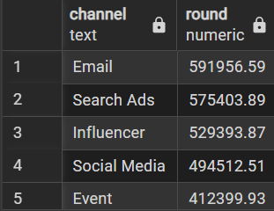

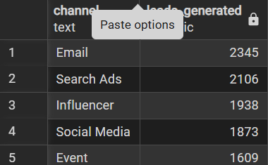
2. Leads Generated: Number of potential customers acquired.

3. Conversions: Number of customers who made a purchase.
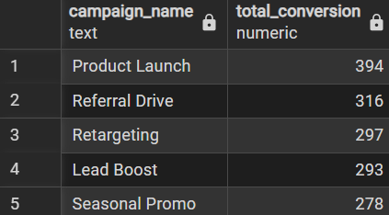

4. Revenue Generated: Total sales attributable to each campaign.
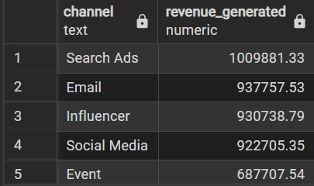

5. ROI (%):
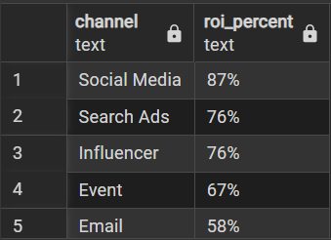

6. Cost per Acquisition (CPA):
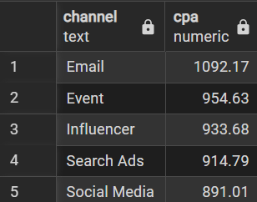
7. Engagement Metrics:
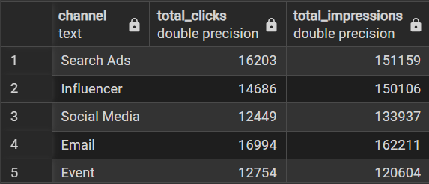

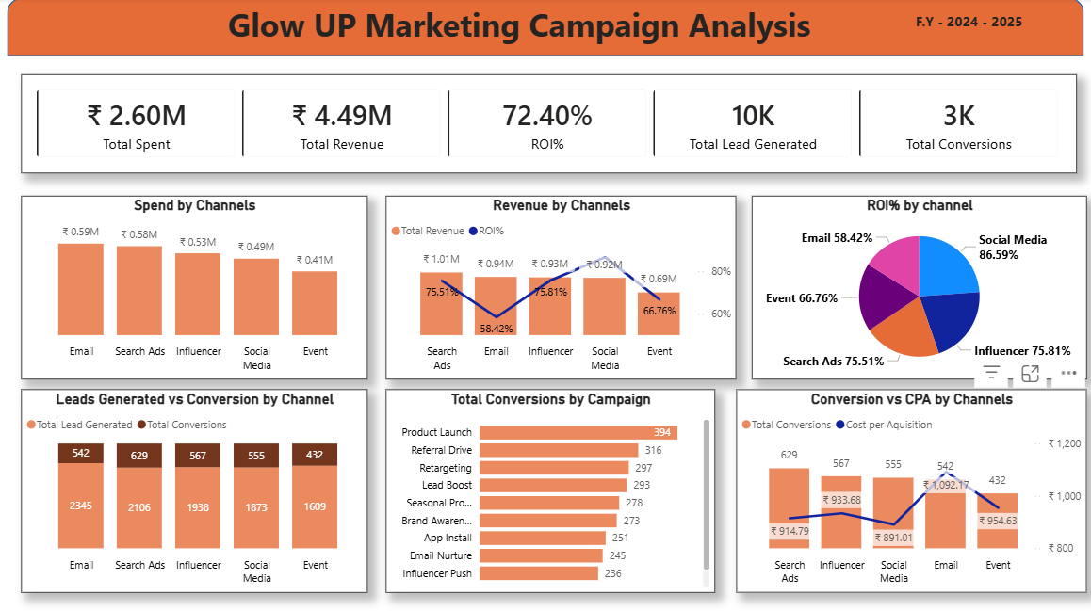

7. Recommendations.
1. Focus on High-ROI Channels (Profit Efficiency)
Social media delivers the highest ROI at 86.59% with a low CPA of ₹891.01 and 555 conversions.
This channel should be prioritized with higher budget allocation and scaled creatives, as it generates strong returns at the lowest acquisition cost.

2. Optimize Spend on Moderate ROI Channels
Email marketing shows the lowest ROI at 58.42% while having the highest CPA of ₹1,092.11 and 542 conversions.
Despite generating 2,345 leads (highest among all channels), its conversion efficiency is weak. Email campaigns should shift toward segmented targeting and drip campaigns instead of volume-based sends.

3. Improve Conversion Efficiency Where Leads Are High
Email generates 2,345 leads but only 542 conversions (~23% conversion rate) compared to Search Ads with 2,106 leads and 629 conversions (~30%).
This indicates lead quality or follow-up gaps in email campaigns. Improve landing page alignment, personalization, and retargeting to convert existing leads more effectively.

4. Strengthen High-Conversion Campaigns
The Product Launch campaign generated the highest conversions at 394, followed by:
- Referral Drive – 316 conversions
- Retargeting – 297 conversions
These campaigns clearly outperform others and should be reused with similar messaging, targeting, and timing in the next quarter.

5. Reduce High CPA Impact
Email CPA is ₹1,092.11, significantly higher than:
- Social Media – ₹891.01
- Search Ads – ₹914.79
Reducing spend on low-performing email creatives and reallocating budget toward social media and Search Ads will help improve overall ROI without increasing total spend.

6. Reallocate Budget Based on ROI Contribution
Current spend is relatively evenly distributed, but ROI is not:
- Social Media ROI: 86.59%
- Search Ads ROI: 75.51%
- Influencer ROI: 75.81%
- Event ROI: 66.76%
Future budget should Favor social media and Search Ads, while Events and Email should undergo optimization before further scaling.

7. Improve Overall ROI Through Retargeting
Retargeting delivered 297 conversions, placing it among the top 3 campaigns.
Increasing retargeting frequency using leads from email (2,345 leads) and social media (1,873 leads) can significantly lift conversions without proportional spend increases.

8. Conclusion
The analysis of the Glow UP Marketing Campaign (FY 2024–25) clearly shows that performance varies significantly by channel and campaign. Social media emerges as the strongest performer, delivering the highest ROI of 86.59% at the lowest CPA of ₹891.01, making it the most cost-efficient channel. Search Ads contribute the highest number of conversions (629) with a solid ROI of 75.51%, confirming their importance in driving scalable growth.
Campaign-wise, Product Launch (394 conversions), Referral Drive (316), and Retargeting (297) consistently outperform others and should be treated as core growth drivers. On the other hand, Email marketing, despite generating the highest leads (2,345), shows the lowest ROI at 58.42% and the highest CPA of ₹1,092.11, indicating inefficiencies in lead quality, targeting, or follow-up.
Overall, future performance can be improved by reallocating budget toward high-ROI channels, optimizing underperforming ones, strengthening retargeting efforts, and focusing on proven campaign types. By adopting a data-driven allocation strategy and improving conversion efficiency rather than increasing spend, the business can maximize ROI, reduce acquisition costs, and achieve sustainable growth in the next quarter.

